Highly Secure and Fast AES Algorithm Implementation on
FPGA with 256 bit key size
Amrik Singh, Research Scholar, University of Petroleum & Energy Studies, Dehradun; & Associate Professor, Guru Teg Bahadur Institute of Technology, Delhi, amrik.singh.prof@gail.com
Dr. Yoginder Talwar, Scientist, National Informatics Centre, Delhi. talwar@nic.in
Dr. Ajay Prasad, Professor, University of Petroleum & Energy Studies, Dehradun;
aprasad@ddn.upes.ac.in

Abstract

The Block cipher AES is a symmetric key cryptographic standard used for transferring block of data in secure manner for server based communication networks, SCADA systems for Oil refinery, Oil and Gas Pipe Lines, and Smart Grids based applications. High level security of data transfer needs long key size i.e. 256 bits, analysis of certain ideas of round key expansion mechanisms from given key data are discussed and the same is implemented in FPGA configuration with 128 bits and 256 bits key size to achieve low latency, high throughput with high security.

Keywords: Advance Encryption Standard, encryption, decryption, FPGA, VHDL, Virtex-5

- Introduction

In AES encryption, the input plain text and output cipher text with a block size of 128 bits and can be viewed as a 4x4 matrix of 16 bytes arranged in a column major format. It can use a key size of 128, 192, or 256 bits and correspondingly has 10, 12 or 14 iterations of round transformations respectively. Each round transformation has four sub transformations namely; Byte Substitution (BS), Row Shift (RS), Mix Column (MC), and Add Round Key (AK). In the last round Mix Column (MC) transformation is not included. The round keys are derived from the user defined cipher key as per the key schedule involving two components a) Key Expansion mechanism and b) Round key selection. The total number of expanded key bytes required for a complete cipher run is equal to the no. of block length bytes (N_{b}) multiplied by the number of rounds (N_{r}) plus one. i. e. N_{b} ( N_{r}+1). Thus the total number of expanded key bytes for key size of 128, 192, and 256 bits is going to be 176, 192, and 240 bytes respectively. The increasing of a given secure key to 256 bit size results in increasing the total no. of possible codes from 2¹²⁸ to 2²⁵⁶ and in turn good secured codes also increases accordingly. The brute force code breaking time will also get increased. The key expansion mechanism for 256 bits key size is considered to be the more secure for data block size of 128 bits whose implementation using FPGA will be discussed in this paper.

Highly secured AES algorithm implementation in FPGA data system is needed to protect data transmission between SCADA Control Server and Corporate Server of our critical integrated Corporate Industries of Petroleum, Electric Power Grids, Information Centre, Sever water control Infrastructures from cyber-attacks of national enemies, terrorist and disgruntled employees.

FPGA implementation scheme for AES algorithm has been chosen because of its low system development cost and development time, in turn has short marketing time for a product, in comparison to ASIC system designs. The product can be updated for improved performance by reprogramming its software since FPGA has the flexibility in redesign variations in FPGA. An FPGA implementation is an intermediate method between general purpose processors (GPPs) and application specific integrated circuits (ASICs), which is better than both GPPS and ASICs. FPGA scheme has wider applications than ASICs because its configuring software has broad range of functionality supported by reconfigurable nature of FPGAs. This scheme is also faster hardware solution than a GPP [7, 9, 11, and 13].
This paper deals with an FPGA implementation of AES encryption/decryption with data block size of 128 bits and key size of 256 bits, simulation and synthesis report results are compared with the other implementations as listed under [5, 6, 9, 10, 11, 12, and 13]. Our design uses key expansion module to generate round keys calculated as per theoretical calculations given in section 2 for key size of 256 bits, which matches exactly with that the key expansion of 256 bits cipher given in NIST documents. Our design approach uses lookup table approach implementation for S-box to achieve low latency as well as high throughput and is low complexity architecture.

2.0 Modified Key Expansion of 128 bit key of AES in terms of bytes

The key expansion of 128-bit key size in AES is defined in the following manner.
The expanded key of N_{b}*(N_{r}+1) =44 words is derived from the 4 words of the user defined key.
The first four (=4) words, W [0], …, W(3) of the expanded key are filled with the use defined original cipher key bits. The subsequent key words for all N_{k}≤ i < ( N_{b}*(N_{r}+1))i.e. 4≤ i <44 alternatively i = (4,…, 43) are given by:

W [i- N_{k}] ⊕ Rotbyte (bs(W[i-1])) ⊕ Rcon (i/ N_{k}) $∀$ i = 0 (N_{k})
W [i] =
W [I - N_{k}] ⊕ W [i-1] $∀$ i ≠ 0 (N_{k})

First 4* N_{k} (=16) bytes, defined as K⁰_{j}: (k₀, k₁, k₂, …, k₁₅) of the expanded key are filled with the original 128 user defined bits in endian format. For subsequent rounds, the expanded key bytes at
n = {16, …, 175} are given by the following relations:
- When n =0(mod 4* N_{k}), the four consecutive key bytes at n to n+3 locations are obtained through:

K_{n} = k_{n-16} ⊕ bs (k_{n-3}) ⊕ Rc(n/16)

K_{n+1} = K _{(n+1)-16} ⊕ bs((k_{n-2}))

K_{n+2} = K _{(n+2)-16} ⊕ bs(k_{n-1})

K_{n+3} = K _{(n+3) - 16} ⊕ bs(k_{n - 4})

- The subsequent expanded key bytes for a particular round i.e. from (n+4)th byte to (n+15)th byte of kn, are obtained through: k_{n} =k_{n-16} ⊕ k_{n-4}

Alternatively, these expanded key bytes can be obtained in the form of round keys K^{i}_{j} through the following relations with the original key bytes filled at i = 0 & j=0,…, 15 in K⁰_{j .}
For 0≤ i < 10

K^{i+1}₀ = K^{i}₀ ⊕ bs(K^{i}₁₃) ⊕ Rc (i+1)

K^{i+1}₁ = K^{i}₁ ⊕ bs(K^{i}₁₄)

K^{i+1}₂ = K^{i}₂ ⊕ bs(K^{i}₁₅)

K^{i+1}₃ = K^{i}₃ ⊕ bs(K^{i}₁₂)

K^{i+1}₄ = K^{i}₄ ⊕ bs(K^{i}₁₃) ⊕ Rc (i+1) ⊕ K^{i}₀

K^{i+1}₅ = K^{i}₅ ⊕ bs(K^{i}₁₄) ⊕ K^{i}₁

K^{i+1}₆ = K^{i}₆ ⊕ bs(K^{i}₁₅) ⊕ K^{i}₂

K^{i+1}₇ = K^{i}₇ ⊕ bs(K^{i}₁₂) ⊕ K^{i}₃

K^{i+1}₈ = K^{i}₈ ⊕ bs(K^{i}₁₃) ⊕ Rc (i+1) ⊕ K^{i}₀ ⊕ K^{i}₄

K^{i+1}₉ = K^{i}₉ ⊕ bs(K^{i}₁₄) ⊕ K^{i}₁ ⊕ K^{i}₅

K^{i+1}₁₀ = K^{i}₁₀ ⊕ bs(K^{i}₁₅) ⊕ K^{i}₂ ⊕ K^{i}₆

K^{i+1}₁₁ = K^{i}₁₁ ⊕ bs(K^{i}₁₂) ⊕ K^{i}₃ ⊕ K^{i}₇

K^{i+1}₁₂ = K^{i}₁₂ ⊕ bs(K^{i}₁₃) ⊕ Rc (i+1) ⊕ K^{i}₀ ⊕ K^{i}₄ ⊕ K^{i}₈

K^{i+1}₁₃ = K^{i}₁₃ ⊕ bs(K^{i}₁₄) ⊕ K^{i}₁ ⊕ K^{i}₅ ⊕ K^{i}₉

K^{i+1}₁₄ = K^{i}₁₄ ⊕ bs(K^{i}₁₅) ⊕ K^{i}₂ ⊕ K^{i}₆ ⊕ K^{i}₁₀

K^{i+1}₁₅ = K^{i}₁₅ ⊕ bs(K^{i}₁₂) ⊕ K^{i}₃ ⊕ K^{i}₇ ⊕ K^{i}₁₁

2.1 Notations and Notions for 256 keys

We use the data block size of 128 bits and key size of 256 bits here, use 14 rounds of iterations of round transformations.
Let for all round index i= 0,…, 14 and data byte index j=0,…, 14; key byte index l= 0,…,31;

X ^{i}_{j} : j th text byte of i th round (in particular, X⁰_{j} is the initial input plain text byte and is fixed).

X¹⁵_{j} : j th cipher text byte.

K ^{i}_{l} : l th expanded key byte of i-th round (in particular K⁰_{l} is the user defined key : k⁰_{l} : (k₀, k₁, k₂, …, k₃₁))

W [i] = i-th key word of 32 bits.

K _{n} : nth key byte, n= {0, 1, 2, …, 239}

N _{k}= (key size) /32 =256/32=8.

N _{b}= (block size) /32=128/32=4.

N_{r}= No. of cipher rounds =14.

2.2 Modified Key Expansion of 256 bits key:

The key expansion of 256-bit key size in AES is defined in the following manner.
The expanded key of N _{b}*(N_{r}+1) =60 words is derived from the 8 words of the user defined key.
The first 8 words, W[0], …, W[7] of the expanded key are filled with the user defined original cipher key bits stored in big endian format. The subsequent key words for all N _{k}≤ i < ( N _{b}*(N_{r}+1))i.e. 8≤ i <60 alternatively i = (8,…, 59) are given by:

First 4* N _{k} (=32) bytes, defined as K⁰_{j}: (k₀, k₁, k₂, …, k₃₁) of the expanded key are filled with the original 256 user defined bits in big endian format. For subsequent rounds, the expanded key bytes at
n = {32, …, 239} are given by the following relations:

- When n =0(mod 4* N _{k}), or in particular at n= 32,64,96,128,160,192,224, the four consecutive key bytes at n to n+3 locations are obtained through:
K _{n} = k_{n-32} ⊕ bs (k_{n-3}) ⊕ Rc (n/32)

K_{n+1} = K _{(n+1) -32} ⊕ bs ((k_{n-2}))

K_{n+2} = K _{(n+2) -32} ⊕ bs(k_{n-1})

K_{n+3} = K _{(n+3) -32} ⊕ bs(k_{n-4})

- When n= 4(mod 32), ( or in particular n= 48, 80, 112, 144, 176, 208) the four consecutive key bytes in n to (n+3) locations are obtained through:

K _{n} = k _{n-32} ⊕ bs [k_{n-4}]

K _{n+1} = k _{(n+1) -32} ⊕ bs [k_{n-3}]

K _{n+2} = k_{(n+2)} ₋₃₂ ⊕ bs [k_{n-2}]

K _{n+3} = k_{(n+3) -32} ⊕ bs [k_{n-1}]

- The subsequent expanded key bytes for a particular round i.e. from (n+4) th byte to (n+31)th byte of k _{n}, (or rest of n=33 to 239) are obtained through:

K _{n} =k_{n-32} ⊕ k_{n-4}

These expanded key bytes can be represented in the form of round keys K ^{I} _{j} with round index i and byte
Index j , through the following relations with original key bytes filled at i = 0 & j = 0, …, 31 in K ⁰ _{j} .
The expanded key bytes for the subsequent rounds i.e. 0 ≤ I < 8 are obtained through the following relations:

K^{i+1}₀ = K^{i}₀ ⊕ bs(K^{i}₂₉) ⊕ Rc (i+1)

K^{i+1}₁ = K^{i}₁ ⊕ bs(K^{i}₃₀)

K^{i+1}₂ = K^{i}₂ ⊕ bs(K^{i}₃₁)

K^{i+1}₃ = K^{i}₃ ⊕ bs(K^{i}₂₈)

K^{i+1}₄ = K^{i}₄ ⊕ bs(K^{i}₂₉) ⊕ Rc (i+1) ⊕ K ^{i} _{o}

K^{i+1}₅ = K^{i}₅ ⊕ bs(K^{i}₃₀) ⊕ K ^{i} ₁

K^{i+1}₆ = K^{i}₆ ⊕ bs(K^{i}₃₁) ⊕ K ^{i} ₂

K^{i+1}₇ = K^{i}₇ ⊕ bs(K^{i}₂₈) ⊕ K ^{I} ₃

K^{i+1}₈ = K^{i}₈ ⊕ bs(K^{i}₂₉) ⊕ Rc (i+1) ⊕ K ^{I}₄ ⊕ K ^{I} ₀

K^{i+1}₉ = K^{i}₉ ⊕ bs(K^{i}₃₀) ⊕ K ^{I} ₅ ⊕ K ^{i} ₁

K^{i+1}₁₀ = K^{i}₁₀ ⊕ bs(K^{i}₃₁) ⊕ K ^{I} ₆ ⊕ K ^{I} ₂

K^{i+1}₁₁ = K^{i}₁₁ ⊕ bs(K^{i}₂₈) ⊕ K ^{I} ₇ ⊕ K ^{I} ₃

K^{i+1}₁₂ = K^{i}₁₂ ⊕ bs(K^{i}₂₉) ⊕ Rc (i+1) ⊕ K ^{I} ₈ ⊕ K ^{I}₄ ⊕ K ^{I} ₀

K^{i+1}₁₃ = K^{i}₁₃ ⊕ bs(K^{i}₃₀) ⊕ K ^{I} ₉ ⊕ K ^{I} ₅ ⊕ K ^{i} ₁

K^{i+1}₁₄ = K^{i}₁₄ ⊕ bs(K^{i}₃₁) ⊕ K ^{I} ₁₀ ⊕ K ^{I} ₆ ⊕ K ^{I} ₂

K^{i+1}₁₅ = K^{i}₁₅ ⊕ bs(K^{i}₂₈) ⊕ K ^{I} ₁₁ ⊕ K ^{I} ₇ ⊕ K ^{I} ₃

K^{i+1}₁₆ = K^{i}₁₆ ⊕ bs {(K ^{I} ₁₂ ⊕ K ^{I} ₈ ⊕ K ^{I}₄ ⊕ K ^{I} ₀ ⊕ bs(K ^{I} ₂₉) ⊕ Rc (i+1)}

K^{i+1}₁₇ = K^{i}₁₇ ⊕ bs { K ^{I} ₁₃ ⊕ K ^{I} ₉ ⊕ K ^{I} ₅ ⊕ K ^{i} ₁ ⊕ bs (K^{i}₃₀)}

K^{i+1}₁₈ = K^{i}₁₈ ⊕ bs { K ^{I} ₁₄ ⊕ K ^{I} ₁₀ ⊕ K ^{I} ₆ ⊕ K ^{I} ₂ bs (K^{i}₃₁)}

K^{i+1}₁₉ = K^{i}₁₉ ⊕ bs { K ^{I} ₁₅ ⊕ K ^{I} ₁₁ ⊕ K ^{I} ₇ ⊕ K ^{I} ₃ ⊕ bs (K^{i}₂₈)}

K^{i+1}₂₀ = K^{i}₂₀ ⊕ K ^{i+1} ₁₆

K^{i+1}₂₁ = K^{i}₂₁ ⊕ K ¹⁺¹ ₁₇

K^{i+1}₂₂ = K^{i}₂₂ ⊕ K ^{i+1} ₁₈

K^{i+1}₂₃ = K^{i}₂₃ ⊕ K ^{i+1} ₁₉

K^{i+1}₂₄ = K^{i}₂₄ ⊕ K ^{i+1} ₂₀

K^{i+1}₂₅ = K^{i}₂₅ ⊕ K ^{i+1} ₂₁

K^{i+1}₂₆ = K^{i}₂₆ ⊕ K ^{i+1} ₂₂

K^{i+1}₂₇ = K^{i}₂₇ ⊕ K ^{i+1} ₂₃

K^{i+1}₂₈ = K^{i}₂₈ ⊕ K ^{i+1} ₂₄

K^{i+1}₂₉ = K^{i}₂₉ ⊕ K ^{i+1} ₂₅

K^{i+1}₃₀ = K^{i}₃₀ ⊕ K ^{i+1} ₂₆

K^{i+1}₃₁ = K^{i}₃₁ ⊕ K ^{i+1} ₂₇

2.5 Expanded Round keys for 256 bits key:

Upon substituting the values in the expanded individual keys, it is observed that each round has a set of 32 bytes of the expanded key depending on the original 32 key bytes in the following pattern.
K₀ to K₃₁ are filled with the user defined key values. Subsequent key values are obtained using the following relation.

K₃₂ = k₀ ⊕ bs(k₂₉) ⊕ Rc₁

K₃₃ = k₁ ⊕ bs(k₃₀)

K₃₄ = k₂ ⊕ bs(k₃₁)

K₃₅ = k₃ ⊕ bs(k₂₈)

K₃₆ = k₄ ⊕ k₃₂

K₃₇ = k₅ ⊕ k₃₃

K₃₈ = k₆ ⊕ k₃₄

K₃₉ = k₇ ⊕ k₃₅

K₄₀ = k₈ ⊕ k₃₆
…
…
…

K₄₇ = k₁₅ ⊕ k₄₃

K₄₈ = k₁₆ ⊕ k₄₄

K₄₉ = k₁₇ ⊕ k₄₅

K₅₀ = k₁₈ ⊕ k₄₆

K₅₁ = k₁₉ ⊕ k⁴⁷

K₅₂ = k₂₀ ⊕ k₄₈

K₅₃ = k₂₁ ⊕ k₄₉
…
…
…

K₆₃ = k₃₁ ⊕ k₅₉
…
…
…

K₂₃₉ = k₂₀₇ ⊕ k₂₃₅

These 32 byte oriented expanded round key of 256 bit may be calculated, stored for immediate use for operations in Mobile hand held systems rather than using look up tables, which will reduce memory requirements, for processing data in low end Spartan FPGA chips.

3.0 FPGA Implementation of AES with 128 bits security key:

Plain text data of 128 bits is encrypted using 128 bits round key in 10 rounds as shown in Fig.1 on left side and cipher text data is decrypted using the same set of round key but using in reverse order for decryption. For data encryption operation, in round one to round nine we perform BS, SR, MC, and AK transformation during each round and in round ten MC transformations is not included. For data decryption operation, the reverse order of rounds is followed. We perform inverse SR, inverse BS immediately after initial AK transformation using round key 10. During remaining 9 decryption rounds the same order of inverse transformations is used, but including inverse MC transformation in the beginning of the every round with round key number in reducing order. After last of AK transformation we get original plain text output data.

The input secret key of 128 bits is expanded into key for ten rounds of 128 bits each. The 128 bits secret key expansion operation is shown in Fig.2. Round key0 is used for first AK operation with plain text data during start of encryption. Round key1 is used for AK operation during round1 of encryption. Round key2 to round key10 are generated for AK operations, for rounds 2 to 10 as shown in the figure. Round keys generated during encryption are stored and utilized for AK operations of decryption also but are used in reverse direction.

When start pulse is given to the controller module, clock pulse, reset pulse, enable pulse and en/de pulse are generated by controller module. Controller module sends first reset and clock pulses to key generation module and encryption / decryption module, then send 0/1 signal to encryption/ decryption module for encryption or decryption operation depending signal level is 0 or 1 respectively. The input security key of 128 bits and input plain text / cipher text of 128 bits data are entered in key generation module and encryption / decryption module, respectively, on getting enable pulse from controller module as shown in Fig. 3. The encrypted/decrypted data of 128 bits is outputted at output port, and done pulse is generated by encryption/decryption module.

R Con [10]
Round Key 10

Round Key 9

+
+
+
+
+
Sub Byte
R Con [2]

R Con [1]

Round Key 1

Round Key 0

+
+
+
+
Sub Byte
+
+
+
+
Sub Byte
+
K0 K1 K2 K3
K4 K5 K6 K7
K8 K9 K10 K11
K12 K13 K14 K15
+
W36
W37
W38
W39
W4
W5
W6
W7
W40
W41
W42
W43
W0
W1
W2
W3

Fig. 2. 128 bits Security key expansion operation.

3.1 FPGA Implementation of AES with 256 bits security key:

Data transmission security level has been enhanced by using a secure key of 256 bit in place of 128 bit size and accordingly 240 bytes round expanded keys will be generated for fourteen rounds in place of 176 bytes for ten rounds respectively. The block diagram scheme for generation of round keys has been modified as shown in Fig. 4 in place of Fig. 2. Plain text data of 128 bits is encrypted in 14 rounds as shown in Fig.3 on left side and cipher text data is decrypted using the same set of round key but using in reverse order for decryption. For data encryption operation, in round one to round thirteen we perform BS, SR, MC, and AK transformation during each round and in round fourteen MC transformations is not included. For data decryption operation, the reverse order of rounds is followed. We perform inverse SR, inverse BS immediately after initial AK transformation using round key 14. During remaining 13 decryption rounds the same order of inverse transformations is used, but including inverse MC transformation in the beginning of the every round with round key number in reducing order. After last of AK transformation we get original plain text output data.
The input secret key of 256 bits is expanded into key for fourteen rounds of 128 bits each. The 256 bits secret key expansion operation is shown in Fig.4. The first half of 128 bits of given 256 bits security key are termed as round key0 and the second half as round key1. Round key0 is used for first AK operation with plain text data during start of encryption. Round key1 is used for AK operation during round1 of encryption. Round key2 to round key14 are generated for AK operations, for rounds 2 to 14 as shown in the figure. Round keys generated during encryption are stored and utilized for AK operations of decryption also but are used in reverse direction.

When start pulse is given to the controller module, clock pulse, reset pulse, enable pulse and en/de pulse are generated by controller module. Controller module sends first reset and clock pulses to key generation module and encryption / decryption module, then send 0/1 signal to encryption/ decryption module for encryption or decryption operation depending signal level is 0 or 1 respectively. The input security key of 256 bits data and input plain text / cipher text of 128 bits data are entered in key generation module and encryption / decryption module, respectively, on getting enable pulse from controller module as shown in Fig. 5. The encrypted/decrypted data of 128 bits is outputted at output port, and done pulse is generated by encryption/decryption module.

128 bit plain text data 256 bits security key data 128 bits Plain text data
W (0,3)
W (0,3)
Add round key
Add round key
Key Exp
Bytes subs

Round 1 Round 1
Inv. Bytes subs
Shift rows
Mix columns
Bytes subs

Shift rows

Inv. Shift rows
Inv. Misc column
Add round keys key
Add round keys
\
W (4,7)
W (4,7)

Round 13 Round 13
Inv. Byte subs

Inv. Bytes subs

W (52,55)

Mix columns

Add round keys
Bytes subs

Shift rows
W (52,55)
Inv. Shift rows

Inv. Mix column
Add round key

Round 14 Round 14
W (56,59)
Inv. Bytes subs

Add round keys
Inv. Shift rows

128 bits cipher text
Add round key
128 bits cipher text
W (56,59)

Encryption Decryption
Fig.3. Data Encryption and Decryption with 256 bits security key

K0,K1,K2….K14
K15
Shift Byte
+
+
+
+
+
+
+
+
K31
K16, K17….K30
ROUND KEY 0
ROUND KEY 1
Shift Row
Sub Byte
+
W0 | W1 | W2 | W3
W4 | W5 | W6 | W7
ROUND KEY 2
ROUND KEY 2

R Con [1]

ROUND KEY 3

W8 | W9 | W10 | W11

Shift Row
Sub Byte
ROUND KEY 4
+
+
+
+
+

R Con [2]

W12 | W13 | W14 | W15

Shift Byte
+
+
+
+
+
+
+
+
+
Shift Row
Sub Byte
ROUND KEY 12

W52 | W53 | W54 | W55

ROUND KEY 13
R Con [14]

W56 | W57 | W58 | W59

ROUND KEY 14

Fig. 4 256 Bits AES Security Key Expansion Operation

Reset

14 Round keys Data
Generation entity

Security key (255-0 )

Encryption/ Decryption entity

En/ Dr

Encryption/Decryption data(127-0)

Done

Controller
Start

Plain text/ cipher text
Input data (127 - 0)
Enable
En/ Dec
CLK

Fig. 5 Top Level Entity of Encryption and Decryption.

4.0 Simulation and Synthesis Results of 128 bit key:

The design has been coded using VHDL and all the results are synthesized based on Xilinx ISE Software 12.4 version and target device used was xc5vtx240t-2-ff1759. The results of simulation of encryption/decryption with security key of 128 bits with 128 bits input data, all 128 bits of one value are shown in Fig. 6. We find encrypted data at transmitter output as quite in random order, since AES algorithm ensures good dispersion and confusion of transmitted data. Simulation results also show that input plain text data is properly ciphered in encryption operation and when ciphered text is given as input to decryption operation, deciphered data is found to be the original input data of encryption operation. All the round keys generated during encryption operation are found to be the same as given in NIST documents for security key of 128 bits.

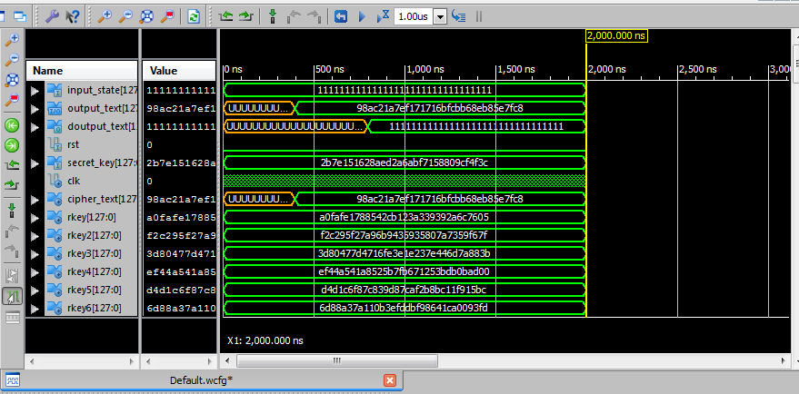

Fig. 6 Simulation results with all the 128 input data bits as “ones”.

Synthesis reports for 128 bits security key are generated for AES algorithm based on Xilinx ISE software 12.4 versions for target device xc5vtx240-2-ff1759 are generated. Synthesis report data generated is given below.

1. No. of ROMs : 360
2. No. of Flip Flops: 10240
3. No. of input and output pins: 515
4. No. of Slice LUT’s: 19974
5. Clock period: 2.115nS
6. Maximum Frequency: 472.82 MHz
7. Delay: 2.115nS
8. Throughput: 64 GBPS
4.1 Simulation and Synthesis Results

The design has been coded using VHDL and all the results are synthesized based on Xilinx ISE Software 12.4 version and target device used was xc5vtx240t-2-ff1759. The results of simulation of encryption/decryption with security key of 256 bits with 128 bits input data, all zero value and all 128 bits of one value are shown in Fig. 8 and Fig. 9 respectively. Simulation results shows that input plain text data is properly ciphered in encryption operation and when ciphered text is given as input to decryption operation, deciphered data is found to be the original input data of encryption operation. All the round keys generated during encryption operation are found to be the same as given in NIST documents for security key of 256 bits [1, 2, 4, and 8].

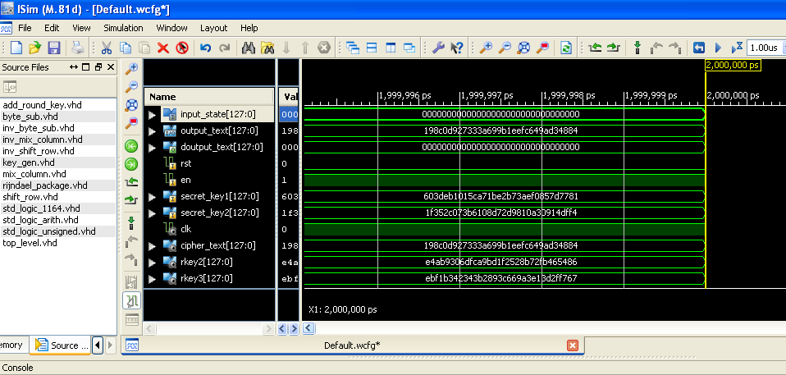

Fig. 7 Simulation results with all the 128 input data bits as ‘’zeros’’.

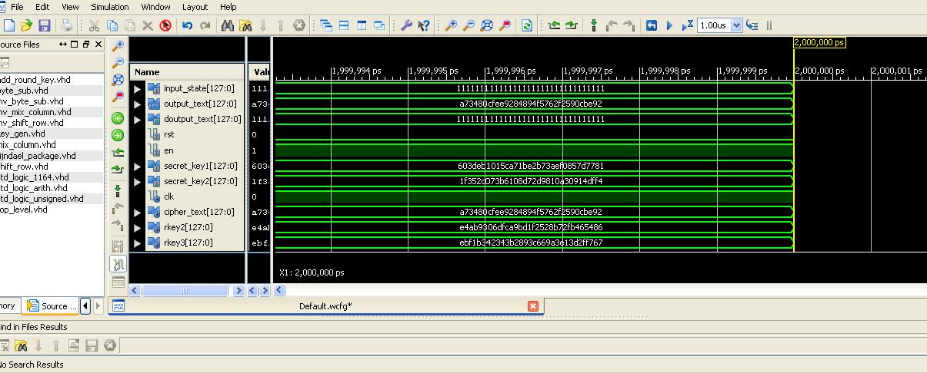

Fig. 8 Simulation results with all the 128 input data bits as ‘’ones’’.

Synthesis report for 256 bit security key is generated for AES algorithm based on Xilinx ISE software 12.4 versions, for target device xc5vtx240-2-ff1759, the report data is given below.

1. No. of ROMs: 500
2. No. of Flip Flops: 14336
3. No. of input and output pins: 642
4. No. of Slice LUT’s: 27517
5. Clock period: 2.115nS
6. Maximum Frequency: 472.82 MHz
7. Delay: 2.115nS
8. Throughput: 64 GBPS

5.0 Comparisons of results of AES algorithm with 128 bit and 256 bit security keys

Two schemes of FPGA implementations of 128 bit data block size with 128 bits security key and 256 bits security key respectively have been presented in this paper along with results reported by other authors. The comparative table clearly shows that our pipe lined architecture using look up tables for S-blocks are better in terms of latency, throughput and higher security with 256 bits security key.

Design | Device used | Area/Slices used | Throughput Megabits/sec | Throughput Megabits/Slice | Maximum frequency in MHz
1. K. Gaj & P. Chodowiec [5 ] | XCV1000BG560-6  XC2S30-6 | 2902  222; GRAM-3 | 331.5  166 | -----  0.132 | -----  60
2. Dandalis [ ] | XCV-1000 | 5673 | 353.0 | 0.062 | -----
3. Elbirt et.al [10 ] | XCV1000-4 | 10992;  BRAM-0 | ----- | ----- | 31.8
4. Mcloone [12 ] | XCV812E-8 | 2000;  BRAM-224 | ----- | ----- | 93.3
5. Helion | Virtex 4-11 | 1016 | ----- | ----- | 200.0
6. G. Rouvroy | XC3S50-4 | 163  BRAM-3 | 208 | 1.26 | 71
7. Swinder Kaur [9 ] | Virtex2 p-7 | 6279; BRAM-5 |  |  | 119.95
8. Amandeep [13 ] | XC2VP30-5-FF896 | 1127 | ----- | ----- | 247.3
9. Thulasimani [11] | XC-2V600BF-957-6 | 2943 | 666.7 | 0.226 | -----
10. Our Design AES-  128 bits security  key | XC5VTX240T-2FF  1759-2 | 10240;  BRAM-0 | 4720 | 0.460 | 472.8
11. Our Design AES-  256 bits security  key | XC5VTX240T-2FF  1759-2 | 14336;  BRAM-0 | 4720 | 0.329 | 472.8

Table : Comparison of results for FPGA implementation of AES

6.0 Conclusions

This system requires 515 input and output ports for the proposed FPGA implementation. The requirement of input and output ports is very large, which can be reduced considerably by using internal serial to parallel registers for input security key and input data respectively, and parallel to serial register for output data inside FPGA device to reduce pin count from 384 to 3 for I/O ports. A few research papers have been reported with security key of 256 bits, but need is felt for increasing the security level for AES implementation. In this paper an attempt has been made for designing highly secured AES Implementation on FPGA with long size key for data transmission between Server system and other connected corporate business computers for Petroleum Industry and other Industries. Hand held mobile secured system is also suggested for field application design, using S-Box optimized by composite field arithmetic (CFA) method for reducing multiplication inversion calculations to reduce chip area and cost and security enhanced by using masking technique of S-Boxes data.

References

[1] J. Daemen and V. Rijmen. AES proposal: Rijndael. In AES Round 1 Technical Evaluation, NIST
1998. (see: http:// www.esat.kuleven.ac.be/rijmen /rijndael/, http://www.nist.gov/aes)
[2] N. ferguson, R. Schroeppel, D. Whiting. A simple algebraic representation of Rijndael,
Selected Area in Cryptography, SAC 2001, LNCS 2259, Springer-Verlag, 2001, pp.103-111.
[3] Courtois, N.T. and J. Pieprzyk: Cryptanalysis of Block Ciphers with over defined Systems of
Equations. Accepted by, Asiecrypt 2002, Dec 2002. (See: http://eprint.iacr.org/2002/044).
[4] Y. Talwar, C.E. Veni Madhavan, N. Rajpal, “On the key expansion mechanisms of the AES
Ciphers: Rijndael, Serpent”.
[5] P. Chdowiec, K. Gaj, “Very compact FPGA implementation of the AES algorithm”, Cryptographic
hardware and embedded systems (CHES 2003), LNCS vol. 2779, pp. 319-333, Springer-Verlog,
October 2003.
[6] G. Rouvroy, F.X. Standaert, J.J. Quisquater, J.D. Legat, , Compact and efficient
encryption/decryption module for FPGA implementation of the AES Rijndael very well suited for
small embedded applications, Proceedings of the international conference on Information Technology: coding and computing 2004 (ITCC 2004), pp. 583-587, vol. 2, April 2004.
[7] Tim Good and Mohammed Benaissa, “AES on FPGA from the Fastest to the Smallest”, CHES
2005, LNCS 3659, pp. 427-440, 2005. Springer-Verlog Berlin Heidelberg 2005.
[8] Y. Talwar, C.E. Veni Madhavan, Navin Rajpal, “On Partial Linearization of Byte Substitution
Transformation of Rijndael-The AES”. Journal of Computer Science 2(1): 48-52, 2006,
ISSN1549-3636 © 2006 Science Publications.
[9] Swinder Kaur and Prof. Renu Vig, “Efficient Implementation of AES Algorithm in FPGA Devices”.
International Conference on Computational intelligence and Multimedia Applications 2007, DOI
10.1109/ICCIMA-2007.250, pages 179-187,0-7695-3050-8/07, IEEE-(2007) Volume2, pp 179-187.
[10] A. J. Elbirt, W. Yip, B. Chatwynd and C. Paes, “An FPGA implementation and performance
Evaluation of the AES block cipher candidate algorithm analyst”, Presented at Proc.3rd AES Conf.
(AES). Available: http:// csrc.nist.gov/encryption/AES/round2/conf3/aes3 paper.html.
[11] Thulasimani L. and Madheswarn, “A Single Chip Design and Implementation of AES-128/192/256
Encryption Algorithms”, International journal of Engineering Science and Technology (IJEST);
ISSN: 0975-5462, Vol.2(5), 2010, 1052-1059.
[12] M. McLoone and J. V. McCanny, “Rijndael FPGA implementation utilizing look-up tables” , in
IEEE Workshop on Signal processing systems, Sept. 2001, pp. 349-360.
[13] Amandeep Kaur, Puneet Bhardwaj and Naveen Kumar, “FPGA Implementation of Efficient
Hardware for the Advanced Encryption Standard”, in IJITEE; ISSN: 2278-3075, Volume-2, Issue-3, ebruary 2013.

Amrik Singh got graduation in Electronics and Telecommunication Engineering from Institution of Engineers, Kolkata, India, Master in Engineering in Electronics and Communication Engineering branch, Delhi College of Engg., University of Delhi. Presently he is working as Ph. D Research Scholar (part time) at University of Petroleum and Energy Studies, Dehradun, India. He is working as Associate Professor in ECE Department, Guru Tegh Bahadur Institute of Technology, New Delhi.

Dr. Yoginder Talwar received his graduation in Electronics and Telecommunication Engineering from Institution of Electronics and Telecommunication Engineers, New Delhi, received his Master in Engineering from Delhi College of Engineering, University of Delhi, India in 1998, and received his Ph. D from Guru Gobind Singh Indraprastha University, Delhi, India in 2006. Presently he is working as senior Scientist in Cyber Security Department at National Informatics Centre, New Delhi.

Dr. Ajay Prasad received his Ph.D. in Computer Science and Engineering, in the area of Cloud security, M. Tech. in Computer Science & Engineering, MCA, B.Sc. (PCM), and GATE in 2006. He has more than 14 years teaching experience at various Institutions. He is reviewer in reputed journals and is Life Member of various reputed professional Organizations. Presently he is a Professor in the department of Information Technology, University of Petroleum and Energy Studies, Bidoli, Dehradun.

